PAWS
Player’s Guide

© 2008 by Roger Plowman
The author grants the right to freely distribute this document so long as no fee is charged for such copies, the contents are not altered in any way, and attribution is retained. Permission is granted to convert this document to different file formats so long as such conversion does not change the meaning or clarity of the text and illustrations. This notice must be retained in all copies.

This document is for those who only want to play games with PAWS, not write games. So if you’re a player trying to see what you need, this is the book for you!
Chapter 1 Download The Pieces 3
What We Expect You To Know Already 3
How Much You’re (Not) Going To Pay 3
Where To Find What You Need 3
How To Install Python 3
How To Install PAWS 3
Chapter 2 How To Run PAWS Games 4
Game Files 5

Chapter 1
Download The Pieces

What We Expect You To Know Already
- How to use a Windows computer (Windows 2000, XP, or Vista). This book covers Windows, if you have a Mac, or a Linux machine, you’ll have to wait for the Linux and OS X versions of this manual (which will appear eventually). PAWS works on nearly any OS, but each OS will have its own way of doing things. We do give some hints to Linux and OS X users though.
- How to use Windows Explorer to create new folders.
- How to download software from the Internet and install it on your computer.
- How to unzip a downloaded file.

How Much You’re (Not) Going To Pay
That’s easy. Nada. Nil. Nothing. PAWS is free, and interactive fiction games are free. Well, you do have to pay for the electricity to run your computer…
You need 3 things from the Internet: PAWS, Python, and wxPython.
You need a folder to download everything into, and another folder to hold PAWS and the game(s) you’re going to play. I use C:\Downloads for my downloads and C:\PAWS Games for my games, but you can use anything you like, PAWS is self-contained in whatever folder you run it from.

Where To Find What You Need
My GitHub page (https://github.com/Moonbase59/PAWS) is a great central point to find everything you need. From the website itself download PAWS 2.0 PLAYER EDITION (if you haven’t already done so!).
Also use the link to go to the Python site. Click the Download button on the left side of that site and download the Windows installer for Python 2.5.1—you can’t miss it. Do the same for the wxPython site, you’re going to want the win32-unicode installer. Note that OS X and Linux also have wxPython installers if you’re using those OSes instead of Windows.

How To Install Python
- You need to log in as administrator (if you run as administrator all the time, shame on you!).
- Install Python. Accept all the defaults in the installation program.
- Install wxPython. Accept all the defaults, wxPython does everything automatically.
- Log out of Administrator and back into your normal account.

How To Install PAWS
- Copy PAWS20Player.ZIP into the PAWS Games folder.
- Unzip the file’s contents, make sure you unzip sub-folders as well.
- After unzipping, the folder should contain some files and a folder named PAWS.
- Congratulations, you’re ready to play!

Chapter 2
How To Run PAWS Games
You should see a file called LoadTerminal.py. Simply double-click this file (this works in Linux and OS X too). When you do so you’ll see the PAWS terminal:
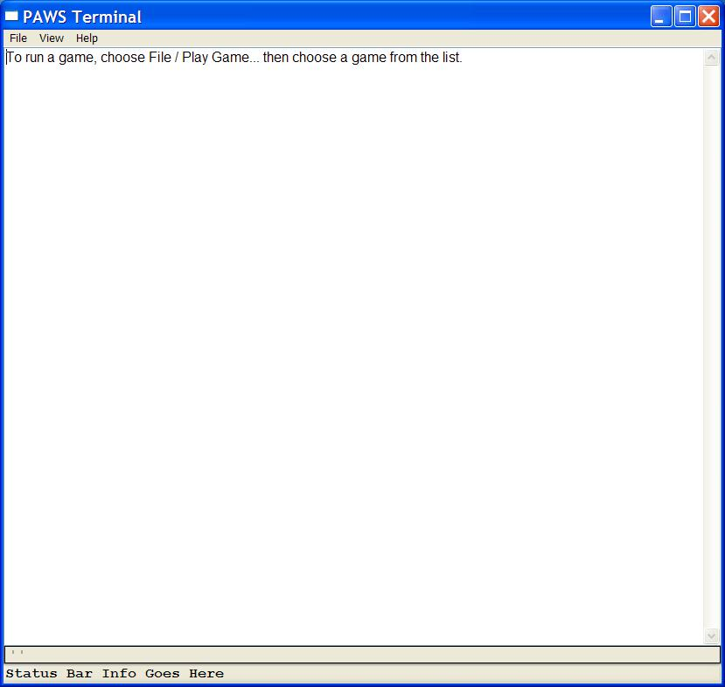

To pick a game, just click File on the menu bar, then click Play Game… A dialog appears, just double-click the game you want to play from the list. Games always have a .py extension, just don’t click LoadTerminal! If you do you’ll see a message telling you that LoadTerminal isn’t a game. Then you can try again.

Game Files
PAWS comes with two sample games:
Cloak.py Cloak Of Darkness, a very small sample game.
TQ.py Thief’s Quest. A large sample game.
Any other PAWS games you get from the Internet should be put in the same folder as the sample games.

